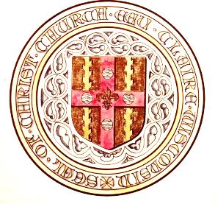
Christ Church Cathedral
Office of the Dean
510 South Farwell Street
Eau Claire Wisconsin 54701
715.835.3734
ccceauclare@gmail.com
www.christchurcheauclaire.org

14 September 2017
The Exaltation of the Holy Cross

Dear Sisters and Brothers in the diocese of Eau Claire,

Greetings in the Holy Name of our Lord Jesus Christ. On behalf of the entire Christ Church Cathedral community, I am delighted to invite you to join us in Eau Claire for the 89th Annual Convention of our beloved diocese. It will take place Friday and Saturday, November 10th and 11th, 2015. We will be joined by the Rt Rev’d Susan Goff, Suffragan Bishop of Virginia, who will address the assembly after dinner.

There will be a banquet dinner at the convention, on Friday evening. I am delighted to announce that due to our recent renovation and building projects, the catered banquet and all of the convention functions can all be held in the Cathedral’s Great Hall for the first time in many years. Accommodation is being offered at a discounted rate for convention attendees by three different locations in Eau Claire: The Oxbow Hotel, the Lismore Hotel, and America’s Best Value Inn and Suites. The Oxbow and Lismore are both newly remodeled downtown hotels, within an easy walk or drive to the Cathedral, but with a slightly higher rate. America’s Best Value is very reliable and affordable, but is a little further away. All three offer some limited breakfast options, and the Cathedral will offer a continental breakfast on Saturday as well. Any hotel accommodation needs to be booked by Saturday October 28, two weeks prior to convention. There will also be a luncheon at the Cathedral following our festival Eucharist on Saturday. Registration for convention, and reservations for the banquet and the luncheon are requested by November 1. There is a form enclosed which can be returned with checks, or payment and information can be submitted online at http://christchurcheauclaire.com/index.php/news/diocesan-convention-2017 .

Our Cathedral Family looks forward to welcoming all of you and to serving you during your time in Eau Claire. We are delighted to be able to celebrate the milestone of our new building project together with our Diocesan Family for the first time.

Yours in Christ,

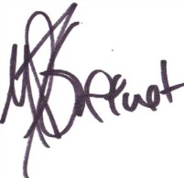
TVR Michael P.T. Greene,
Dean and Rector
Diocese of Eau Claire
89th Diocesan Convention—2017
Eau Claire, WI
Registration Form

Convention Registration (check appropriate boxes)
Name of Attendee | Clergy $20 Registration | Delegate $20 Registration | Vendor $50 Registration | Alternate  No fee | Observer  No Fee | Friday Banquet* $25 Reservation | Saturday Luncheon $12  Reservation | Totals
Total

*Semi-formal Catered Buffet Supper with several options, including vegetarian
**Informal homemade soup and sandwich luncheon provided by members of the Cathedral Community

